- Describe XACML and SAML
Ans:
XACML:
XACML is an abbreviation to eXtensible Access Control Markup Language.

XML is often known to define its own tags and document structures of web pages through XHTML and as a result, is used widely in storing and transmitting data.

Similarly, XACML is a Markup Language, but it serves a very different purpose.
XACML is a specific markup language. Its usage mainly includes defining access
control policies in a computer system.

As we know, access control serves as one of the primary shields to prevent unauthorized access and thus contributes to web- security. Thus
XACML comes in handy when there are multiple systems involved and we need a standard through which we can define access control.

Strengths:
- XAML is platform-independent, application-independent, OS independent.
- Can cater to the needs of an organization because it can express complex policies, and implement hierarchical roles, time-bound access, and component-based access control.
- XACML is more finely grained as it considers objects, subjects, and environments for a module/attribute/component for a given role.
- XACML can also be looked upon as a request-response protocol.
Components of XACML:
- Policy Administration Point (PAP) – creates policies for security and stores it in the appropriate repository.
- Policy Decision Point (PDP) – evaluates access using policies.
- Policy Enforcement Point (PEP) – This will enforce the decisions made by PDP.
- Policy Information Point (PIP) – Assists PEP in enforcing PDP.

More on XACML:
Its standards are defined by the technical committee of OASIS.

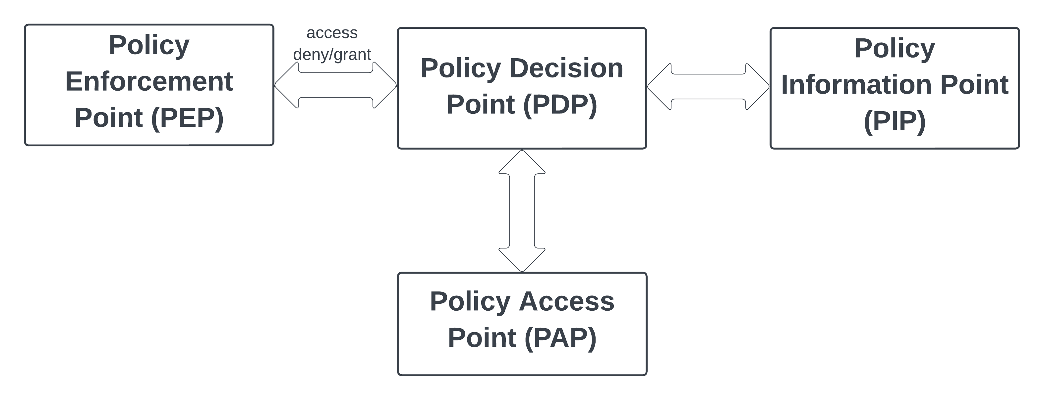
Figure 1: XACML Components

SAML:
SAML is an abbreviation for Security Assertion Markup Language.

The main idea behind this is very analogous to sessions in web apps, wherein we want to allow a user access to a set of web pages throughout the session using a single set of credentials. SAML tends to achieve this by transferring the authentication data (mainly in the form of a token).
Thus, the token is validated for each page, in fact, it is checked for each microservice/API call that is made for a given page, and based on that the data is shielded from unauthorized access.
An example that I have personally used for SAML authentication is the JWT Authorization token (OAuth 2.0). It can be looked upon as an identity provider (IDP) that provides access tokens.
Generally, IDP maintains a directory of users and their information, and the Service provider hosts the target application. SAML passes information about user attributes among IdP and SP.
Evidently, SAML is used to exchange authentication and authorization data among systems. It’s a standardized method to do so, which is why it is highly preferred in integrating it with microservices, and other applications.
SAML provides single-point authorizations with its 3 components namely Assertion, Attributes, and Authorization.
Components of SAML:
- Identity Provider (IdP): Responsible for identifying and giving out a valid access token.
- Service Provider (SP): SP will look at the token provided IdP if validated and grant access to the user.
- SAML Assertion: This is an XML-based document with the user’s identity, authentication, and permissions.
- SAML Protocol: Can be looked at as a set of rules mapped between IdP and SP for access control.
- Metadata: Contains data on the configurations of components involved, endpoints, public keys, etc.

- Describe Security for Web Services
Ans:

A huge portion of web documents is in the form of XML documents.
XML allows us to define our own tags and ow document structures and that is the reason why they are widely used.
Hence keeping those XML files secured becomes a huge part of Data Security for web services.
The basic premise is that XML encryption will provide a shield against confidentiality threats and XML signature will provide a shield against integrity threats.
To access a security service provider, one must provide information that is able to identify the user as the owner (referred to as making the claim).
Major components that provide security for web services are as follows:
WS-Policy:
A WS policy, short for Web Services policy, is a declarative statement that expresses the various capabilities, requirements, and constraints of a Web Service.
It is a formal representation of the rules that govern the interactions between service providers and consumers in a distributed computing environment.
In essence, a WS policy is a set of assertions that describe the non-functional aspects of a given service, and they are security, reliability, and performance, as well as the functional aspects, such as the operations, and messages supported by the service.

WS Trust:
WS Trust, or Web Services Trust, is a specification that defines a framework for establishing trust relationships between different entities in a Web Service environment.
It is designed to address the security challenges of distributed systems by providing a standard mechanism for issuing, renewing, and validating security tokens.
WS Trust enables service providers to authenticate and authorize service consumers by exchanging security tokens, such as SAML, X.509 certificates, and Kerberos tickets. It defines a set of request/response messages that enable the exchange of security tokens and specifies the rules for the creation and validation of those tokens.
In essence, WS Trust provides a foundation for building secure and trusted Web Services by enabling the establishment of trust relationships between different entities in a distributed environment, ensuring that only authorized parties can access and use the services.
WS Addressing:
WS Addressing, or Web Services Addressing, is a standard that defines a way for Web Services to communicate addressing information between each other.
In other words, it provides a mechanism for a Web Service to specify the address of the intended recipient of a message, as well as the source address of the message.
WS Addressing helps to solve the problem of endpoint references, i.e.: it addresses and resolves the endpoint discrepancies used in message exchange, this helps improve scalability, reliability, and interoperability in Web Services.

A few other components involved can be stated as XML Encryption, XML Signature, Security Token, Signed Security Token, XACML, and SAML standards, etc.

- Describe Security for Cloud Computing
Ans:

Over the years, to reduce the overhead on maintenance, easily be able to access data from anywhere and, save on massive investments in hardware stores. Companies, as well as users, have swiftly transitioned to using cloud-based (an extended component of distributed computing) solutions.
However, like any other technological advancement, this also came with its own set of challenges. Moving away from a central storage system, intuitively means that the data needs to be transferred and stored somewhere else.
That itself is one of the weak links that can compromise the security of data and it cannot be overlooked because it directly threatens the confidentiality of sensitive data, data integrity, privacy in communications, and much more.
Thus, Security for the cloud becomes an integral part of the Cloud itself.
Security for cloud computing encompasses a range of security measures, such as authentication, access control, data encryption, and threat detection and response.
It also involves the development and adoption of security policies and procedures, such as security audits and risk assessments, to help ensure that the cloud environment is secure and compliant.
Security Layers:
Security in the cloud can be broken down as security for several layers including physical security, network security, , and access control.
One such classification looks at it as follows:
- Cloud Computing Infrastructure Security Level
- Network Layer – prevents network infrastructure by intercepting attacks, building firewalls (proper access control), etc.
- Host Layer – prevents the host (device/s on which the enterprise is deployed), this includes protecting host OS, deploying HIDS, etc.
Security of OS has more to do with PaaS and SaaS, and host security is passed on to CSP. At the IaaS level, we look at virtualization in software security.
- Application Layer – focuses on the interface between the application and queue manager. Both customer and cloud providers are involved in this layer.
- Cloud Storage and Data Security Level
- Is the Level of protection that cloud service providers offer to ensure the confidentiality, integrity, and availability of their customer’s data.
- It involves implementing security measures such as encryption, access control, backup, and disaster recovery, to protect data from unauthorized access, theft, or loss.
- The level of security can vary depending on the type of data being stored and the sensitivity of that data.
- Identity and Access Management, which involves validating that a person is trusted enough, and has access to is when they are allowed access.
- XACML is considered to be a more favored approach as it provides vivid functionalities that can allow us to define security in a more robust way that is better interpreted.
- Cloud Computing Authorization Management Security Level
- This involves overlooking the aspects of Access control, Availability Management, Vulnerability Management, Privacy, Patch Management, Configuration Management, and so on.
- This can be looked at more as security-as-a-service. Also, the standards followed here are in accordance with ITIL and ISO.
Some cloud service providers (third party) who sell Security-as-a-service are AWS, Right Scale, Google, Microsoft’s Azur, and Salesforce.

- Describe how ABAC may be implemented in an organization.
Ans:
ABAC is a methodical approach to access control that employs logical evaluations of attributes linked to the subject, object, requested operations, and contextual elements, against policies, rules, or relationships dictating acceptable operations based on the aforementioned attributes.
Furthermore, the potential of ABAC in promoting information sharing across and within organizations, while simultaneously ensuring control over the disclosed information.

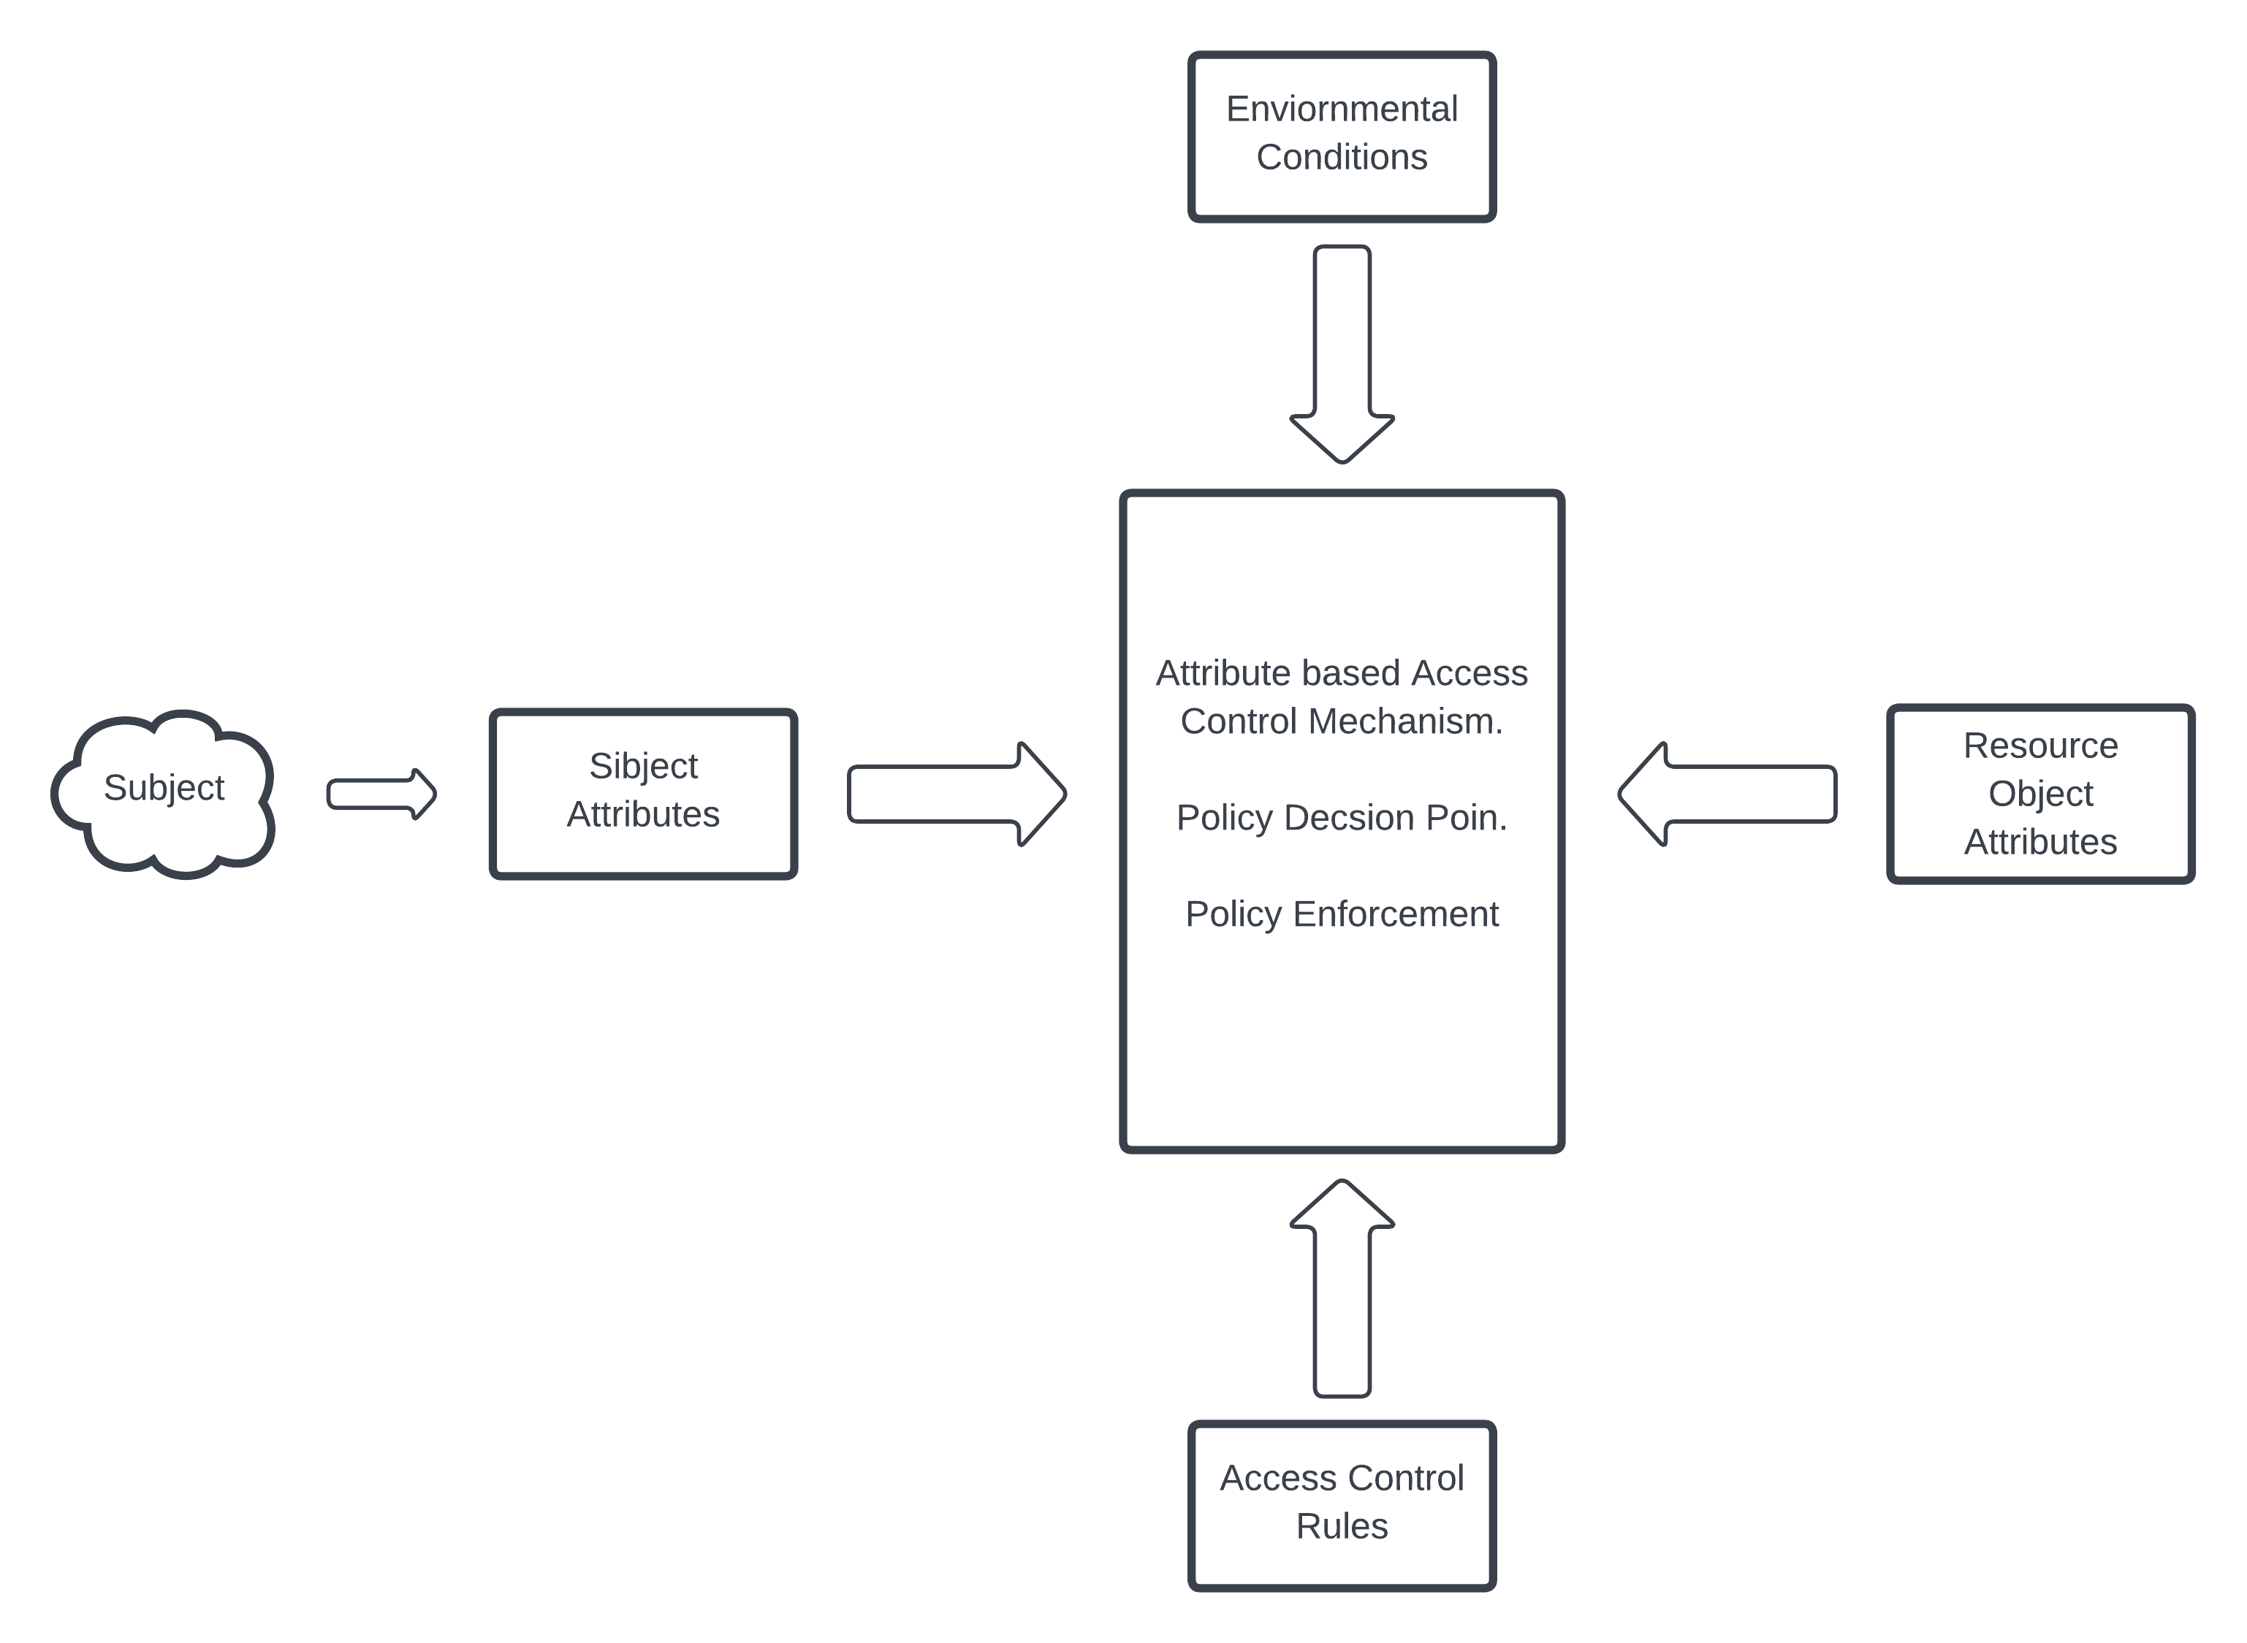
Core ABAC Mechanism [reference - link]

Whenever someone requests access:
- The subject attributes are evaluated by Attribute Based Access Control Mechanism.
- Access Control rules are evaluated by Attribute Based Access Control Mechanism.
- Based on the above evaluations, access control decisions are provided.
- Note that in Attribute Based Access Control Mechanism (ABAC). Both Policy Decision Points, as well as Policy Enforcement Points, are involved.

Steps involved in deploying ABAC systems across the enterprise:

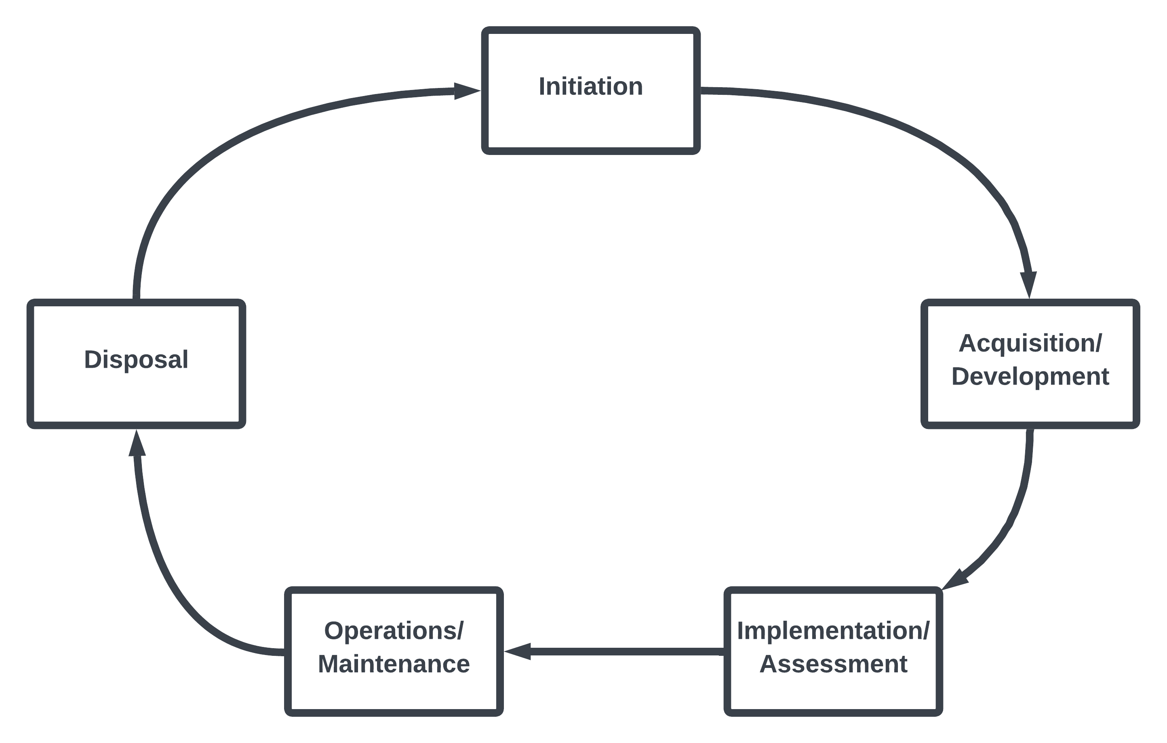
ACM NIST System Development Life Cycle (SDLC) [reference - link]

Initiation Phase:
During the inception phase, the organization assesses the exigency of an Attribute-Based Access Control (ABAC) system and its possible application.
The organization should ascertain whether the ABAC system will be an autonomous information system or a constituent of a previously established system.
Look at scalability, feasibility, and Performance requirements; Focus on developing Operational Requirements and Architecture.
Prior to deploying enterprise ABAC capabilities, an extensive evaluation of necessities, trade studies, and planning activities must be conducted to determine the suitability of ABAC as the appropriate type of access control capability and its feasibility given the application portfolio.
To begin with, identifying objects that require sharing and safeguarding by ABAC
Secondly, defining the rules or policies governing their protection.
Thirdly, identifying and defining subject and object attributes and their corresponding authorities in coordination with access control rule developers.
Fourthly, developing processes concerning the writing, validation, and management of access control policies.
Finally, determine how Access Control Mechanisms (ACMs) will be segmented or distributed throughout the enterprise and how attributes, policy, and decision requests and responses will be rendered.
Acquisition/Development Phase:
Steps involved in the subsequent process include Business Process Generation and Development Preparation. It includes Digital Policy Creation and maintenance, Agreements, and understanding of attributes.
System Development and Solution Acquisition is another factor in this process that involves defining comprehensive standards for an ABAC-based approach.
Also focuses on Data Integrity, seamlessly integrating with several other controls of ABAC, etc.
Implementation/Assessment Phase:
In this phase, the primal focus is on Attributes. Which involves the process of attribute caching that is apparent in low-bandwidth, high-latency environments, Attribute source minimization, and Interface Specification to name a few.
Operations/Maintenance Phase:
Already the products are in place and the system is running, here the focus is on modification, enhancements, and alterations in the pre-existing system.
Hence evidently a lot of testing is also subsequently involved in this process.
Availability of logged data, and other informetric becomes vital to making key decisions in this phase.
Disposal Phase:
This is when we actively stop the upgrades and handle the product to be managed/controlled by the stakeholders.
This can be looked up as the deployment phase in the SDLC lifecycle.

References:

- https://nvlpubs.nist.gov/nistpubs/specialpublications/NIST.sp.800-162.pdf

- https://downloads.cloudsecurityalliance.org/initiatives/secaas/SecaaS_Cat_1_IAM_Implementation_Guidance.pdf

- Describe an approach for Cloud-based Assured Information Sharing
Ans:
Over the years, to reduce the overhead on maintenance, easily be able to access data from anywhere and, save on massive investments in hardware stores. Companies, as well as users, have swiftly transitioned to using cloud-based (an extended component of distributed computing) solutions.
However, like any other technological advancement, this also came with its own set of challenges. Moving away from a central storage system, intuitively means that the data needs to be transferred and stored somewhere else.
That itself is one of the weak links that can compromise the security of data and it cannot be overlooked because it directly threatens the confidentiality of sensitive data, data integrity, privacy in communications, and much more.
Thus, Sharing the data securely over the cloud becomes an integral part of the Cloud itself.
One of the approaches:
- Policy-Based Information Sharing
- Risk determination in information sharing.
- Deploy an active firewall-like algorithm to identify and eliminate untrustworthy requests.

Layered framework for Assured Cloud Computing Model.
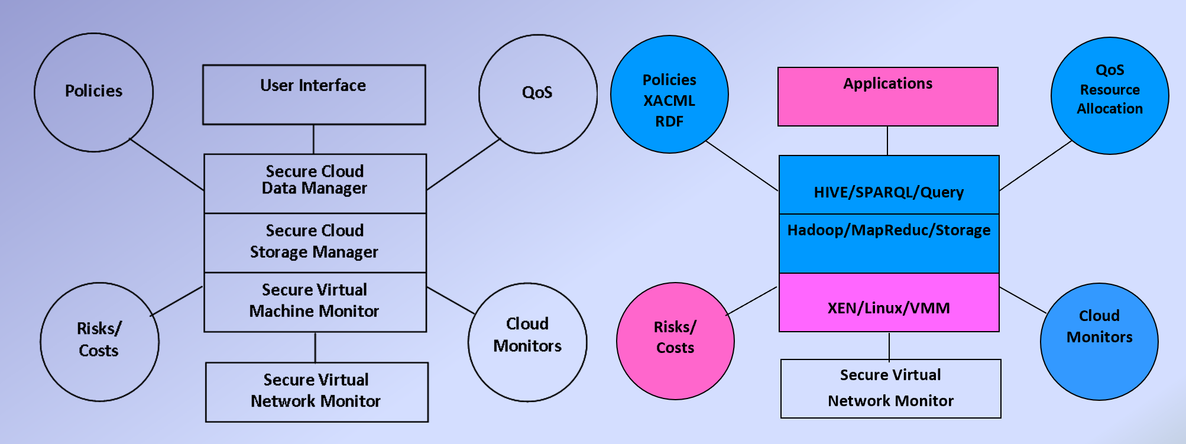
Layered Framework for Assured Cloud
[reference - Lec slide 3-3 page 6]

- Final processed data is handed over to the end user via the Application layer (User Interface)
- Query Processing:
  - Query processing in relational data using HIVE.
  - Query processing in relational data using SPARQL, which is in turn based on RBF or Relational database usually available in the cloud.
- An access control table can be maintained to fine-grain the access control, where XACML policies can be serialized or uploaded directly.
- Based on that the XACML policy builder can implement the access control in relational databases using hive.
- Now the data can be successfully stored in secure cloud using HDFS

- Describe an approach for Cloud-based Malware Detection (Lecture 3-11)
Ans:
Malwares are executables that intend to camouflage as a required program or a function, which once executed, aims to cause harm to a computer system.
A malware threat cannot be overlooked upon, as the roles of malware have been proven over the years.
Challenges ahead of Malware Detection:
- The dynamic nature of the cloud makes it difficult to tackle malware if any.
- Scale of the cloud-based code base is mammoth, and separating out malware from that can be an extremely difficult task.
- A cloud is a distributed environment; thus, the code base does not reside in a monolith device and hence malware could be more difficult to tackle.
- To meet regulatory compliance for data protection and security we might not rely completely on third-party malware detection too.
We need to do all these, while the applications are constantly being running, new data is generated, consumed, and stored and updates/upgrades to the existing system are being carried out simultaneously. This adds up to the complex nature of the task.

One of the approaches for Malware detection is where malware detection is viewed as a Data Stream Approach.
- Here we classify every executable. (Note that executables are runnable files example: .exe) is to be classified in a binary classification as either malicious or benign.
- A well-known method to solve this problem is using static estimation techniques, something like a decision tree.
- But the problem with static estimates is that they are not well suited to an environment that has a continuous influx of data.
- Also, a data stream is a succession of executables under this paradigm and the length of the stream is boundless.
- The problem of classifying data streams is a very hot topic in the Data mining industry/ domain and state-of-art solutions are emerging for this problem.
- This approach could potentially help us identify malware in near-real time, dynamically, and with comparatively less processing and storage costs incurred.
- Kv approach is used to train the model, where k is a hyperparameter and V is the size of ensemble classifiers.
- The data chunk out of the current running windows is divided into n equal parts and new labels are given based on the classifier logic, which updates the labels in real-time with the newest available information
- But this approach has a downside too, classifications could go wrong. 100 percent classification is never guaranteed and there is always an estimate associated, so in malware detection, false positives might not be an issue, but a false negative (i.e.: wrongfully identifying the executable to be benign when it is malicious) can do a lot of harm.
- Hence this is not a fail-proof method and should be used in conjunction with other Malware detection techniques to better secure your organization against possible malware invasion.

References:
Lecture slide 3-11 pages 8 till 14.

- Describe virtualization aspects for the Cloud
Ans:
Virtualization in the cloud is increasing following these reasons,
Cost saving in infrastructure, ease of scalability that too on demand, efficiency and hence better resource utilization, security, etc.
Creating a virtual version of a physical resource (something like a remote desktop) and being able to use the storage, computing power, security, and other features of that remote device on your device can be referred to as Virtualization.
Virtualization within cloud computing facilitates the generation of multiple virtual machines (VMs) on a solitary physical server, where each VM possesses individual operating systems and resources. These VMs can be efficiently and promptly allocated, configured, and expanded or contracted as required, based on the exigencies of the workload.
Forms of virtualization can be distinguished primarily based up on computing architecture layer.
- Application Virtualization:
This virtualization Is only extended to a single application or an API wherein we can use the feature/app installed on a remote server on our device.
One such example is JVM – the Java Virtual machine or something as simple as a pdf converter, wherein we use the logic and framework, and the computation in a remote server using our device.
- Operating System Virtualization:
Provides with a virtual implementation of an OS. i.e.: multiple independent operating systems can run on a single physical computer.
Example is CompTIA that allows using Virtual Linus OS on a window’s device.
- Full Virtualization:
Full virtualization is a technique in virtualization technology where a software layer, known as a hypervisor, is inserted between the physical hardware and the operating system of the host, in order to enable multiple operating systems to run independently and securely on a single physical machine, without being aware of each other's presence or interfering with each other's operations.

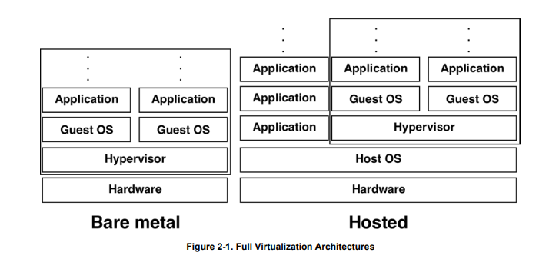
Full Virtualization Architecture [Refernce - Link]
- Bare Metal Virtualization:
The hypervisor, which executes in the absence of a host operating system, operates directly on the fundamental hardware layer and may be integrated into the system's firmware itself.
- Hosted virtualization:
hypervisor works in conjunction with the host operating system, which may be any one of Windows, Linux, or MacOS, and operates atop the guest operating system.
Here, the virtualization program also runs in the guest OS, affording users with utilities to manage the virtualization, such as the facility to exchange files with the host OS.
In contrast to bare metal architectures that can solely support applications within virtualized systems, hosted virtualization architectures facilitate users to simultaneously operate various applications, including web browsers and email clients, alongside the hosted virtualization program.

Yet another classification of virtualization could be in terms of Single Server Virtualization and Multi server Virtualization.
- Describe Cloud monitoring with respect to Hypervisor vs Host/Guest Operating System
Ans:
Cloud monitoring involves the continuous scrutiny and evaluation of cloud-based resources and services to verify that they are operating as intended, meet performance expectations, and comply with security standards.
Cloud monitoring involves using specialized software tools and techniques to track, assess, and troubleshoot cloud-based resources, including applications, infrastructure, and services.
The data collected through cloud monitoring is used to identify any issues that may be impacting the performance or security of the cloud environment, enabling administrators to take corrective action as needed.
This helps ensure that the cloud environment remains stable, secure, and available for end users.
Additionally, cloud monitoring provides valuable insights into resource utilization and performance, which can be used to optimize the cloud infrastructure for better efficiency and cost-effectiveness.

Cloud Monitoring in Hypervisor-Based Virtualization:
- Cloud monitoring in hypervisor-based virtualization involves monitoring the hypervisor layer itself and the virtual machines running on it.
- This includes monitoring hypervisor performance metrics such as CPU usage, memory usage, and network throughput, as well as the performance of individual virtual machines.
- Hypervisor-based monitoring also enables monitoring of the underlying physical hardware and any virtual storage devices or virtual networks being used.
- Additionally, monitoring for security threats such as unauthorized access attempts, data breaches or malware can also be done at the hypervisor level.
- Since the hypervisor is responsible for managing and isolating VMs, it is also responsible for enforcing security policies and detecting security breaches. Hypervisor-based cloud monitoring tools can detect and alert administrators to potential security threats within the virtual environment.
Cloud Monitoring in Hosted Virtualization with a Guest Operating System:
- Cloud monitoring in Host Guest Operating System-based virtualization involves monitoring the operating system layer of both the host and guest machines.
- This includes monitoring resource utilization such as CPU usage, memory usage, and disk space usage for both the host and guest operating systems.
- Host Guest Operating System-based monitoring also enables monitoring of application performance within each guest operating system.
- Furthermore, monitoring can be done for any security threats targeting the operating system or applications running on the guest machines.
- Overall, the type of cloud monitoring used will depend on the virtualization technology being used, but both hypervisor and Host Guest Operating System-based monitoring are essential for maintaining the performance, security, and availability of cloud infrastructure.
- However, since hosted virtualization relies on the host operating system to manage VMs, it may be more vulnerable to security threats at the host level. Hosted virtualization cloud monitoring tools can still detect and alert administrators to potential security breaches but may have limited visibility into security threats within the guest operating systems.

- Describe three attacks to the Cloud
Ans:

Cloud attacks are on the rise due to the increasing adoption of cloud services and the large amounts of valuable data being stored in the cloud, making it an attractive target for attackers.
Additionally, the complexity of cloud environments and the lack of visibility and control for customers can create vulnerabilities that can be exploited.
The types of cloud attacks are as follows
- Man in cloud Attack –
- In this attack, an attacker intercepts the communication between the user and the cloud service provider, allowing them to eavesdrop on the communication or manipulate the data being transmitted.
- This can be accomplished by exploiting vulnerabilities in the network or by using social engineering techniques to trick the user into revealing sensitive information.
- Generally, in such cases, the attacker takes control of the user’s cloud account generally by stealing the authentication token.
- Now this token can be used to seamlessly access all the details/data/ privilages and in some cases make changes that otherwise shouldn’t have been possible.
- To prevent such attacks care should be taken that especially users with high privilage should only and only use a specific set of devices to log in, check the usage logs regularly, have double authentication each time.
- To mitigate the effects if at all the user has come under such an attack is by having a session time that expires after a definite time, so the authentication token will have to be refreshed and re validated.
- Blue Pill attack –
- The Blue Pill attack is a form of virtualization-based rootkit attack on a cloud system where the attacker gains control of the hypervisor layer, allowing them to intercept and modify any guest OS behavior and remain undetected.
- The Blue Pill attack is a type of rootkit-based virtualization attack in which an attacker gains control over a virtual machine (VM) by installing a hypervisor underneath the guest operating system, allowing the attacker to execute malicious code undetected.
- This is accomplished by exploiting vulnerabilities in the hypervisor or hardware virtualization features, enabling the attacker to execute their code in the hypervisor and hide it from the guest operating system.
- Once the Blue Pill is executed, it can manipulate the behavior of the guest operating system, allowing the attacker to gain unauthorized access to sensitive data and resources within the cloud environment.
- Steps to take to ensure that such attacks don’t happen are implanting hardware-level virtualization that cant be bypassed by attackers.
- Employ secure boot technologies to ensure that only authorized and trusted software is loaded at boot time.
- Use encryption technologies to protect sensitive data both at rest and in transit, regularly perform security audits and penetration testing to identify vulnerabilities and weaknesses in the cloud infrastructure.

- Side Channel Attack –
A side-channel attack in the context of cloud computing refers to the exploitation of vulnerabilities in the physical infrastructure or implementation of the cloud system to obtain unauthorized access or sensitive information by analyzing the side effects of physical or software implementations, such as power consumption, electromagnetic radiation, or timing.
This type of attack does not directly target the intended victim, but instead takes advantage of information leakage from other sources to infer sensitive information about the victim's operations or data.
Side channel attacks in cloud can be conducted through multiple channels, including timing, power consumption, electromagnetic radiation, and acoustic emanations.
These attacks exploit weaknesses in the physical implementation of cloud systems to gain access to sensitive data or perform unauthorized actions.
Side channel attacks can be difficult to detect and prevent, as they do not rely on traditional security vulnerabilities and may occur even in systems with strong encryption and access controls.
To prevent such attacks, take measure to implementing cryptographic countermeasures such as randomization, masking and noise injection
Restricting the physical address of the cloud servers, limiting access to sensitive data using strict authentication.
Educating users to the risks associated with side channel attacks.

- Describe security for a cloud product (e.g., AWS, Azure)
Ans:
Over the years, to reduce the overhead on maintenance, easily be able to access data from anywhere and, save on massive investments in hardware stores. Companies, as well as users, have swiftly transitioned to using cloud-based (an extended component of distributed computing) solutions.
However, like any other technological advancement, this also came with its own set of challenges. Moving away from a central storage system, intuitively means that the data needs to be transferred and stored somewhere else.
Security as a service is in demand, and I will discuss the security for AWS, because that is my strong penchant and I am a certified cloud practitioner.
Security is important in AWS cloud to protect sensitive data, ensure compliance with regulations, and maintain the availability and integrity of services.
Major security threats for AWS can be classified as follow:
- Data Breaches - Attackers can obtain valid login credentials, such as usernames and passwords, through phishing attacks or social engineering techniques, and use them to gain unauthorized access to an AWS account. To prevent, we can ensure strong password standards etc.
- DDoS attacks - DDoS attack in AWS involves overwhelming the network with traffic to disrupt its services; prevention includes using AWS Shield, WAF, and configuring auto scaling groups to handle traffic surges.
- Permissions or encryption are insufficient – Insufficient permission or encryption occurs when sensitive data is not adequately protected, making it susceptible to unauthorized access, modification or theft; prevention can be achieved through implementing strong encryption, access control mechanisms, and regular security audits.
- Insecure APIs - Attackers exploit vulnerabilities in APIs to gain unauthorized access to sensitive data or control over the cloud environment. Ensure secure coding practices and use AWS security tools such as AWS Identity and Access Management (IAM) to control access to APIs. Regularly monitor and audit API activity to detect any suspicious behavior.
Besides, some popular points dealing with Security-as-a-service provided by AWS cloud are as follows:
- AWS provides a range of security services to help protect customer workloads.
- These services include identity and access management, network security, and encryption.
- AWS also provides threat detection and incident response services.
- AWS Security Hub is a central location for monitoring security across AWS accounts.
- Amazon GuardDuty is a threat detection service that continuously monitors for malicious activity.
- AWS WAF provides protection against common web exploits.
- Amazon Macie automatically discovers and classifies sensitive data stored in AWS.
- AWS KMS provides key management and encryption services.
- AWS CloudTrail records all API calls and provides visibility into AWS account activity.
- AWS Trusted Advisor provides security recommendations and best practices for AWS architecture.

Overall, we can conclude that In AWS, security is of paramount importance to ensure confidentiality, integrity, and availability of data, and to achieve this, it employs various security measures such as access control, encryption, monitoring, and compliance auditing, as well as offers numerous security services like Security Hub, GuardDuty, and Inspector to provide a comprehensive security solution to its customers.

- Describe how documents may be published securely in the Cloud
Ans:
Publishing documents in the cloud offers many benefits, including easier accessibility, collaboration, sharing, and editing by multiple users from anywhere and any device, as well as lower costs and reduced IT infrastructure requirements.
Publishing documents in the cloud provides several advantages over conventional methods, such as easy access from any device or location, real-time collaboration with multiple users, version control, automated backups, and enhanced security features.
Threats in publishing documents in cloud include unauthorized access, data breaches, and loss of data control.
Hence to here are some methods (cautions) to be aware of when to publishing documents in the cloud more securely:
- Use encryption techniques to protect the confidentiality and integrity of the document.
This can be done using tools like BitLocker, VeraCrypt, or AESCrypt. In addition, many cloud providers also offer encryption options to secure data at rest and in transit.
- Implement access control measures to restrict unauthorized access to the document.
This can be done by creating user accounts with unique usernames and passwords, and assigning appropriate permissions to each user based on their role and responsibilities.
Cloud providers also offer various access control mechanisms, such as IAM policies and resource-based policies, that can be used to manage access to resources in the cloud.
- Use secure transfer protocols such as HTTPS or SFTP to ensure that the document is transferred securely.
When publishing documents in the cloud, it is crucial to use secure transfer protocols such as HTTPS or SFTP to ensure that the document is transferred securely between the client and the server.
HTTPS (Hypertext Transfer Protocol Secure) is a protocol for secure communication over the internet, while SFTP (Secure File Transfer Protocol) is a protocol that uses Secure Shell (SSH) to provide secure file transfers.
These protocols use encryption to secure the data in transit and prevent any unauthorized access or tampering.
- Regularly update and patch the cloud software to prevent vulnerabilities from being exploited.
- Use two-factor authentication to add an extra layer of security to the document access process.
Two-factor authentication (2FA) adds an extra layer of security to the document access process by requiring users to provide two forms of authentication.
In addition to a password, 2FA requires users to provide another form of authentication, such as a fingerprint, a voiceprint, or a security token.
This extra layer of security helps to prevent unauthorized access to the document, even if a password is compromised.
- Monitor and audit the cloud environment to detect any suspicious activity or unauthorized access to the document.
- Train employees on security best practices to prevent human error or insider threats.
- Service Level Agreements (SLAs) is to Choose a cloud service provider that offers robust security measures and guarantees in the form of SLAs can help ensure that the documents are stored and managed securely. SLAs can cover aspects such as availability, data durability, and data security.

So after discussing what all factors that need to be considered before/while and after you upload documents to cloud.
Let me dive into general steps that we should follow in order to upload documents to cloud securely.
- They are as follows:
- Choose a cloud storage provider and create an account.
- Upload the document to the cloud storage platform.
- Determine the access level for the document, such as public or private.
- Share the document with others by providing access through a secure link or granting permission within the platform.

- Describe Governance aspects of the Cloud
Ans:
Governance in the Cloud refers to the establishment and enforcement of policies, procedures, and guidelines that ensure the efficient and effective management of cloud resources.
It involves the creation of a framework that addresses the compliance, risk management, and regulatory requirements of cloud computing.
Governance aspects of the Cloud include the development of strategies for resource allocation, access control, data protection, and incident response.
It also involves the establishment of performance metrics, standards, and accountability mechanisms to ensure that cloud services meet the needs of the organization and comply with legal and regulatory requirements.
The governance aspects of the Cloud are:
- Protecting the Cloud against cyber-attacks and privacy violations –
- Implementing access control mechanisms to restrict unauthorized access to Cloud resources
- Using encryption techniques to secure data at rest and in transit
- Conducting regular vulnerability assessments and penetration testing to identify and mitigate potential security risks
- Complying with relevant privacy laws and regulations, such as GDPR and CCPA, to protect customer data
- Risks and Insurance -
- Identifying and assessing potential risks associated with Cloud adoption
- Developing a risk management strategy to mitigate identified risks
- Considering the need for cyber-insurance to cover potential losses resulting from security incidents or breaches
- Ensuring compliance with insurance policies and regulations related to Cloud services
- Cloud Governance Frameworks -
- Adopting a Cloud governance framework to manage Cloud adoption and operations
- Establishing Cloud policies and procedures that align with organizational goals and regulatory requirements
- Ensuring transparency and accountability in Cloud decision-making and resource allocation
- Monitoring and evaluating Cloud services to ensure compliance with governance policies and regulations
- Artificial Intelligence Strategy -
- Developing an AI strategy that aligns with organizational goals and priorities
- Identifying and prioritizing use cases for AI in the Cloud
- Ensuring data quality and integrity to support AI initiatives
- Addressing ethical and legal considerations related to AI, such as bias and privacy concerns
- Evalutaion, Certification, Accreditation and Standards -
- Conducting independent evaluations of Cloud service providers to assess their security, privacy, and compliance capabilities
- Seeking third-party certifications and accreditations to validate Cloud service provider's security and compliance posture
- Adhering to industry standards and best practices, such as ISO 27001 and NIST, to ensure security and compliance
- Monitoring and auditing Cloud services to ensure ongoing compliance with relevant standards and regulations.

- Describe Trust Management for Hadoop
Ans:
Hadoop is an open-source framework for distributed storage and processing of large datasets. It is designed to handle big data and is based on a distributed file system (HDFS) and a processing engine (MapReduce). Hadoop can be run on commodity hardware and can scale horizontally to handle large amounts of data.
In the context of Hadoop, trust management refers to the mechanisms and policies that are put in place to ensure the security and reliability of the distributed data and processing environment. This includes measures such as authentication and authorization protocols, encryption, and access controls.
Trust management is essential for ensuring that users and applications can trust the integrity and confidentiality of the data and processes within the Hadoop cluster.
Trust management is important in Hadoop as it ensures that only authorized and trusted users have access to sensitive data, which helps in protecting the confidentiality, integrity, and availability of the data stored in Hadoop clusters, ultimately ensuring the overall security of the system.
This ensures that only authorized users are able to access sensitive data, mitigating the risk of data breaches and cyber attacks.
Implementing trust management in Hadoop involves the following steps:
- Set up Kerberos authentication: This involves configuring the Hadoop cluster to use Kerberos, a network authentication protocol that provides strong security for client/server applications. This ensures that only authorized users can access the Hadoop cluster.
- Configure SSL encryption: This involves configuring SSL certificates to encrypt communications between nodes in the Hadoop cluster. This ensures that data is protected from unauthorized access while in transit.
- Set up access controls: This involves configuring the Hadoop cluster to enforce access controls based on user roles and permissions. This ensures that users can only access data and perform operations that they are authorized to.
- Implement auditing and monitoring: This involves setting up auditing and monitoring tools to track and log user activity and system events in the Hadoop cluster. This allows administrators to detect and investigate any suspicious activity or security breaches.
Overall, implementing trust management in Hadoop involves a combination of strong authentication, encryption, access controls, and auditing and monitoring to ensure that data is protected from unauthorized access and malicious activity.

Pros:
- Trust management in Hadoop enables secure data sharing and collaboration across multiple users and organizations.
- It helps in reducing the risk of unauthorized data access and leakage, which can cause reputational and financial damage.
- The implementation of trust management ensures compliance with regulatory requirements related to data privacy and security.
Cons:
- Implementing trust management in Hadoop can be complex and challenging due to the large scale of Hadoop clusters and the diversity of user access requirements.
- Overly restrictive trust policies can impede data sharing and collaboration, leading to reduced productivity and innovation.
- Trust management systems can be vulnerable to attacks, and it requires constant monitoring and updates to stay effective against emerging threats.

- Describe Access Control for MapReduce
Ans:
MapReduce is a parallel programming model and an associated implementation for processing and generating large datasets. It is a programming paradigm that allows for distributed and parallel computing on large datasets using a cluster of computers.
MapReduce involves a two-phase execution model where the map function processes input data and produces a set of intermediate key-value pairs, which are then processed by the reduce function to produce the final output.
This approach allows for efficient and scalable processing of large-scale data sets.
MapReduce is used for large-scale distributed data processing in order to enable parallel processing of data, allowing for faster and more efficient computation on big data.
It is commonly used for tasks such as data mining, machine learning, and processing large amounts of unstructured data.
Access Control refers to the security mechanism that controls the access of authorized users or processes to resources or information, while restricting the access of unauthorized entities.
It involves granting or revoking permissions to access specific resources, based on the identity and privileges of the requester.
Access control in MapReduce refers to the implementation of security mechanisms that restrict unauthorized access to sensitive data and resources in a distributed computing environment.
This involves the enforcement of policies that govern the authentication, authorization, and accountability of users and processes, as well as the management of privileges and permissions at different levels of the system.
The goal is to ensure that only authorized users and applications can access and manipulate data, while preserving the confidentiality, integrity, and availability of the system as a whole.
Access control in MapReduce ensures that only authorized users can access sensitive data or perform specific actions, minimizing the risk of data breaches and insider threats.

By implementing access control in MapReduce, organizations can maintain data confidentiality, integrity, and availability while complying with various regulatory requirements and industry standards.
Steps that can be followed to implement Access Control for Map Reduce:
- Identify the security requirements: Determine the level of access control needed for the MapReduce cluster based on the sensitivity of the data and the risks associated with unauthorized access.
- Implement access control mechanisms: Configure the MapReduce cluster to implement access control mechanisms such as authentication, authorization, and auditing. This can include using Kerberos for authentication, Hadoop Access Control Lists (ACLs) for authorization, and log files for auditing.
- Test the access control mechanisms: Verify that the access control mechanisms are working as intended by conducting security testing and penetration testing. This can include testing for vulnerabilities and attempting to bypass or circumvent the access controls.
- Monitor and maintain the access control mechanisms: Regularly monitor the MapReduce cluster for unauthorized access attempts and maintain the access control mechanisms by applying patches and updates as needed.

Thus we conclude that, Access control in MapReduce can offer benefits such as enhanced security, compliance with regulations, and improved resource utilization. However, implementing access control can also increase complexity, require additional administrative overhead, and potentially impact performance if not properly configured.

